Question 1. Create a correlation matrix and heatmap
# Install packages (run only once)
install.packages("ggplot2")
install.packages("reshape2")

# Load packages
library(ggplot2)
library(reshape2)

# Create dataset
set.seed(14769)
n <- 16

rainfall <- round(rnorm(n, 141.3, 45.1), 1)
grass_height <- round(rnorm(n, 14.1, 3.0) + (rainfall - 141.3) / 45.1 * 0.40, 1)
milk_yield <- round(rnorm(n, 16.5, 4.0) + grass_height / 10, 1)
fert_dev <- round(5.1 + 3.1 * (length.out = n) / n, 1)

crop_damage <- round(pmax(0, 6 - 0.2 * rainfall + rnorm(n)), 1)
tractor_hours <- round(rnorm(n, 6.2, 2.0), 1)
fuel_cost <- round(tractor_hours * 5 + rnorm(n, 0, 2), 1)

df <- data.frame(
rainfall, grass_height, milk_yield,
fert_dev, crop_damage, tractor_hours, fuel_cost
)

# Correlation matrix
cor_matrix <- cor(df)
print(round(cor_matrix, 2))

# Correlation heatmap
cor_long <- melt(cor_matrix)

ggplot(cor_long, aes(Var1, Var2, fill = value)) +
geom_tile(color = "white") +
geom_text(aes(label = round(value, 2)), size = 3) +
scale_fill_gradient2(
low = "blue", mid = "white", high = "red",
midpoint = 0, limits = c(-1, 1)
) +
labs(title = "Correlation Matrix of Dairy Farm Variables",
x = "", y = "", fill = "Correlation") +
theme_minimal() +
theme(axis.text.x = element_text(angle = 45, hjust = 1)) 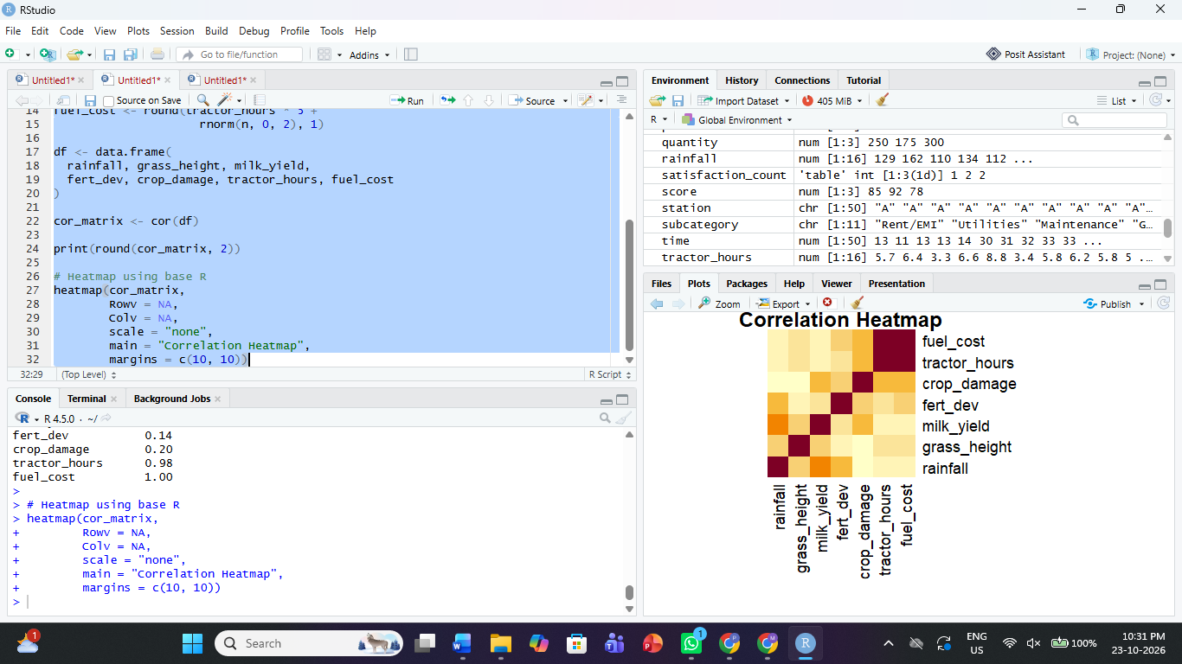
Interpretation: Correlation values range from −1 to +1. Positive values indicate that variables tend to increase together, while negative values indicate that one tends to decrease as the other increases.
Question 2. Identify the strongest clusters
cor_matrix <- cor(df)

cor_pairs <- as.data.frame(as.table(cor_matrix))
names(cor_pairs) <- c("Variable1", "Variable2", "Correlation")

cor_pairs <- cor_pairs[
as.character(cor_pairs$Variable1) <
as.character(cor_pairs$Variable2), ]

cor_pairs <- cor_pairs[
order(abs(cor_pairs$Correlation), decreasing = TRUE), ]

print(cor_pairs) 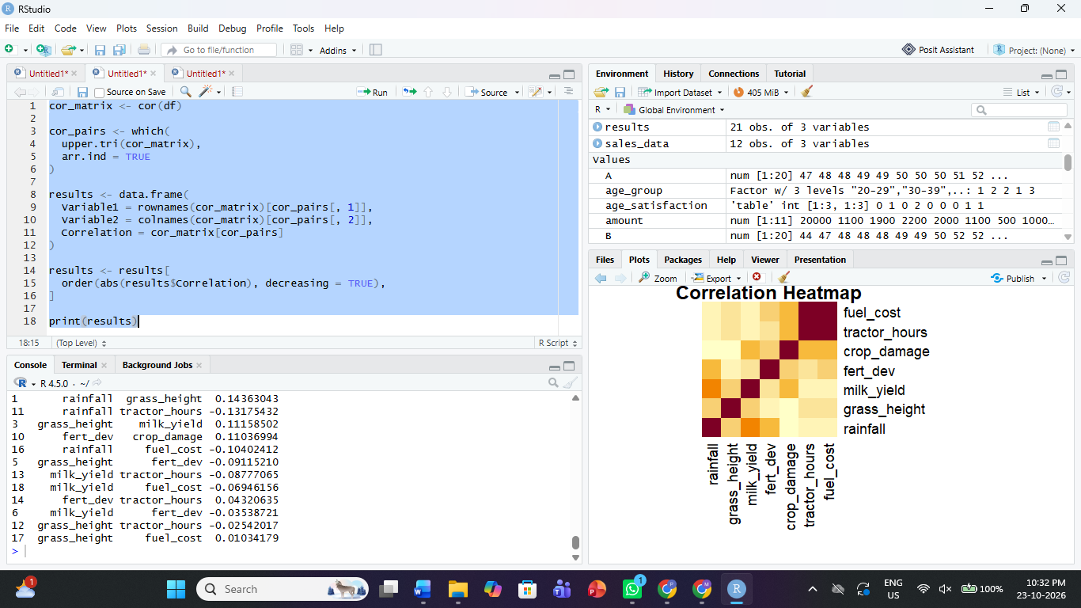
Classify the absolute correlation values as follows:
- Weak: below 0.30
- Moderate: 0.30 to 0.70
- Strong: above 0.70
Use the output to identify the strongest positive and negative pairs. These classifications are guidelines rather than universal statistical rules.
Question 3. Create a deceptive plot between crop damage and fertilizer deviation
library(ggplot2)

ggplot(df, aes(x = fert_dev, y = crop_damage)) +
geom_point(size = 3) +
geom_smooth(method = "lm", se = FALSE, colour = "red") +
labs(title = "Crop Damage vs Fertilizer Deviation",
x = "Fertilizer Deviation",
y = "Crop Damage") +
theme_minimal()

# Correlation and R-squared
r <- cor(df$fert_dev, df$crop_damage)
r_squared <- r^2

cat("Correlation:", round(r, 3), "\n")
cat("R-squared:", round(r_squared, 3), "\n")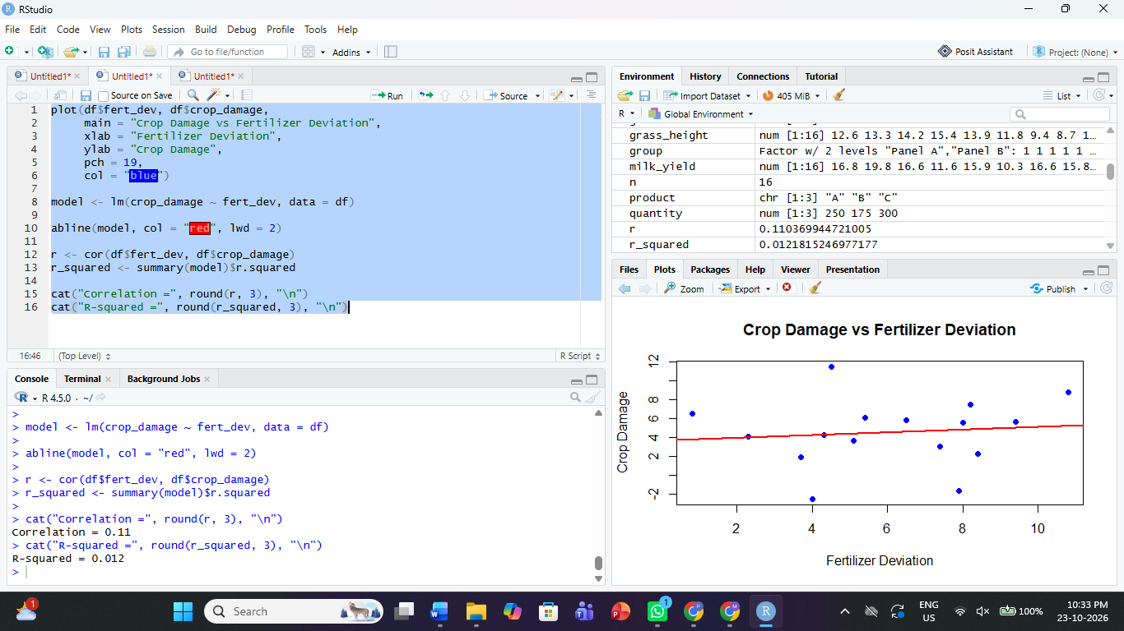
Interpretation: The correlation measures the strength and direction of the linear relationship. The \(R^2\) value indicates the proportion of variation explained by a simple linear model.
A deceptive plot could exaggerate a weak relationship by truncating the axes or using a distorted scale. A better plot uses clearly labelled axes and an appropriate scale.
Question 4. Create a scatterplot between fuel cost and tractor hours
ggplot(df, aes(x = tractor_hours, y = fuel_cost)) +
geom_point(size = 3) +
geom_smooth(method = "lm", se = FALSE, colour = "blue") +
labs(title = "Fuel Cost vs Tractor Hours",
x = "Tractor Hours",
y = "Fuel Cost") +
theme_minimal()

# Detect outliers using the IQR rule
Q1 <- quantile(df$fuel_cost, 0.25)
Q3 <- quantile(df$fuel_cost, 0.75)
IQR_value <- IQR(df$fuel_cost)

lower <- Q1 - 1.5 * IQR_value
upper <- Q3 + 1.5 * IQR_value

outliers <- df[df$fuel_cost < lower |
df$fuel_cost > upper, ]

print(outliers) 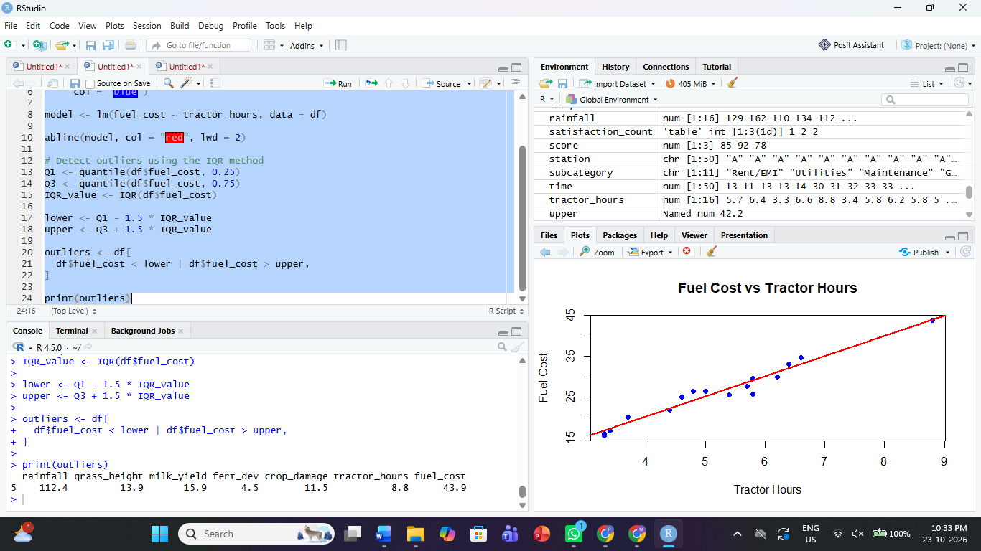
Interpretation: A positive relationship would indicate that fuel cost generally increases as tractor hours increase. Potential outliers should be investigated rather than automatically removed.
Question 5. Identify the main spurious relationship
# Correlation matrix
round(cor(df), 2)

# Scatterplot matrix
pairs(df,
main = "Scatterplot Matrix of Dairy Farm Variables",
pch = 19) 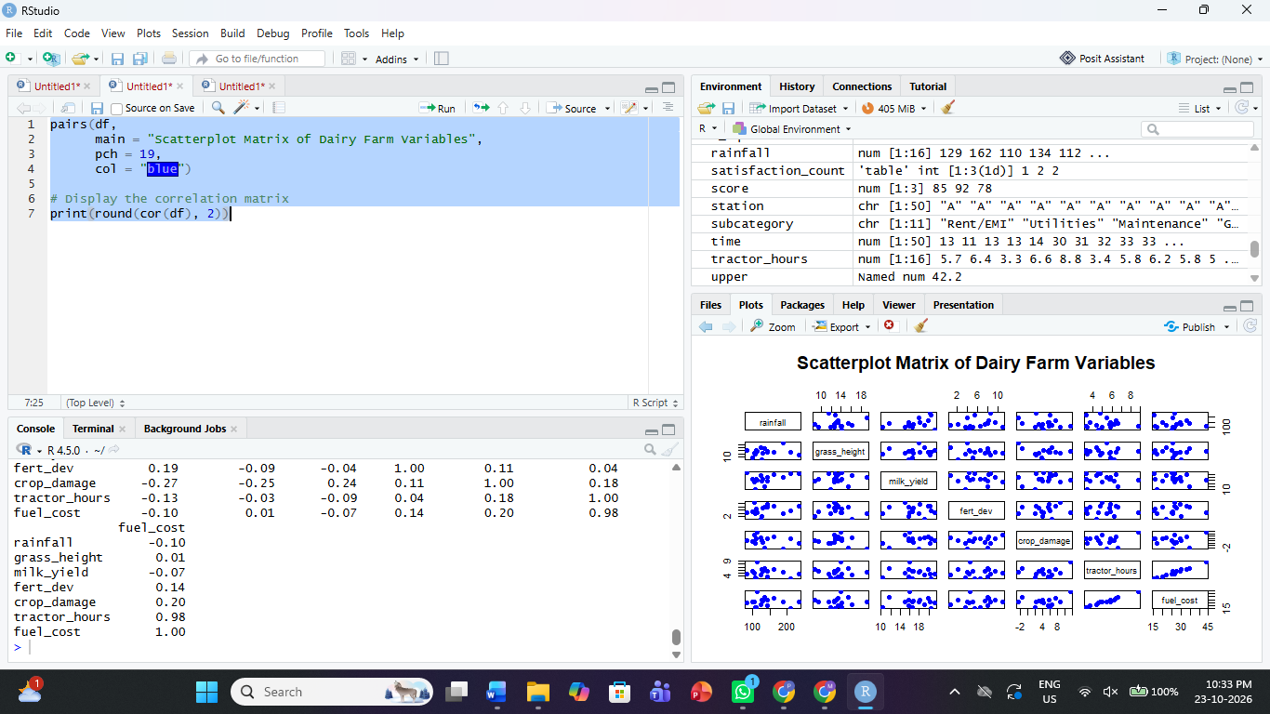
A spurious relationship occurs when two variables appear correlated because of a third variable or a shared underlying trend. For example, rainfall and grass height may both be influenced by seasonal conditions.
Recommendation: Investigate the underlying context before concluding that one variable causes another. Correlation alone does not establish causation.

